## horizontal line



Order Processing System

Database Management Systems Final Project

**─────────────**

**Implementation of a DBMS of an online bookstore.**

# Team Members

|  |  |
| --- | --- |
| Name | ID |
| Engy Ibrahim Mahmoud | 19015478 |
| Yara Hossam Abdelaziz | 19016871 |
| Heba Mostafa Abdelreheem | 19016836 |
| Mariam Mohamed Ahmed | 19017274 |
| Ahmed Abdallah Aboeleid | 19015274 |
| Mohamed Tarek Hussein Aiad | 19016405 |
| Michael Samir Azmy | 19016237 |
| Mohamed Momen salama | 19016474 |
| Abdelrahman Fathy El-Lawaty | 19015920 |
| Mohamed Mostafa Ibrahim | 19016506 |

# 

# Database ERD Diagram

## 

# Analysis

## 

## Triggers

1. Modify_existing_books

Make users cannot update the quantity of a book if this update will cause the quantity of a book in stock to be negative.

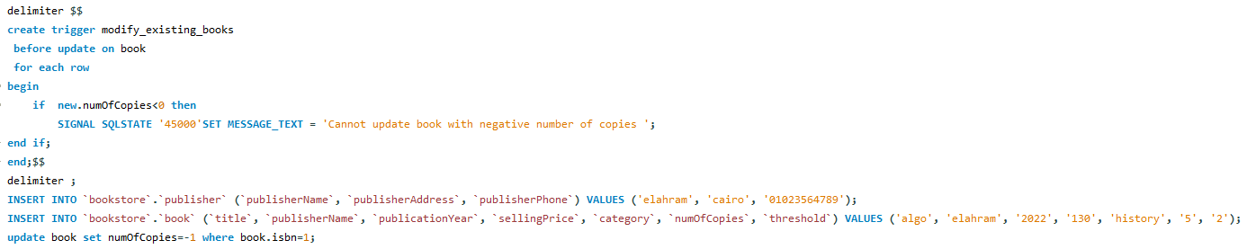

1. Place_order

System order an order with constant quantity is placed only when the quantity of a book drops from above a given threshold , assuming System is a manager with id 0

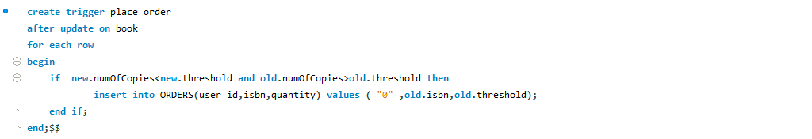

1. confirmOrder

The quantity of the book in store automatically increases with the quantity specified in the order , when manager confirm an order

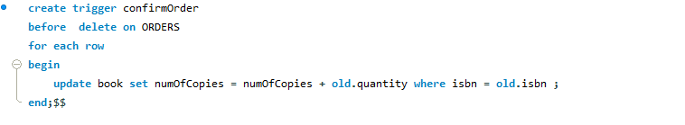

## Indices

Add indices to when search , to optimize the queries

## Database Tuning

To ensure using memory efficiently, a relation is made for publishers instead of keeping a column for publisher in the BOOK relation to avoid redundancy of information as many books may have the same publisher.

Moreover, a relation is created to store managers’ IDs instead of keeping a column of boolean in the USER_INFORMATION relation as the number of managers is much less than the number of users, so storing managers’ IDs is a more cost-effective approach.

## Concurrency / Transaction Control

On checkout from the shopping cart, a transaction is started with an isolation level of Repeatable Read to prevent dirty reads and non-repeatable reads while the user is entering his credit card details. A transaction is committed on confirmation if the credentials are valid. If the user cancels the checkout, the transaction rollback.

On modifying a book, a transaction is started with an isolation level of Repeatable Read to prevent dirty reads and non-repeatable reads while the user is entering the new details of the book. A transaction is committed on confirmation if the new title is unique.

# Sample Screenshots

## User

User Homepage

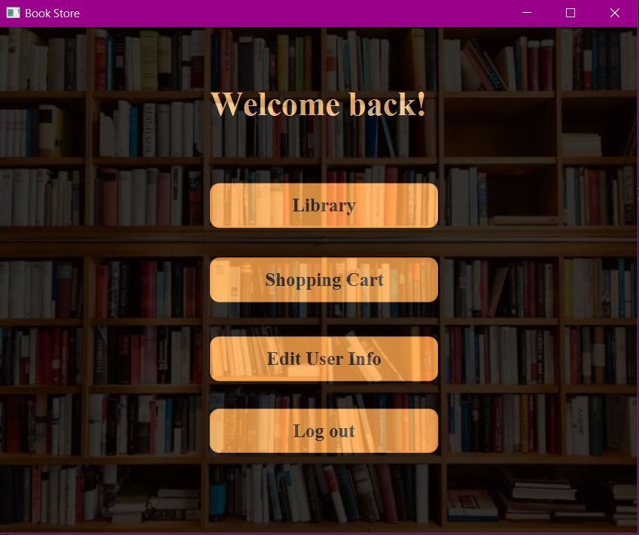

Edit User Info ::

>> before editing fields .

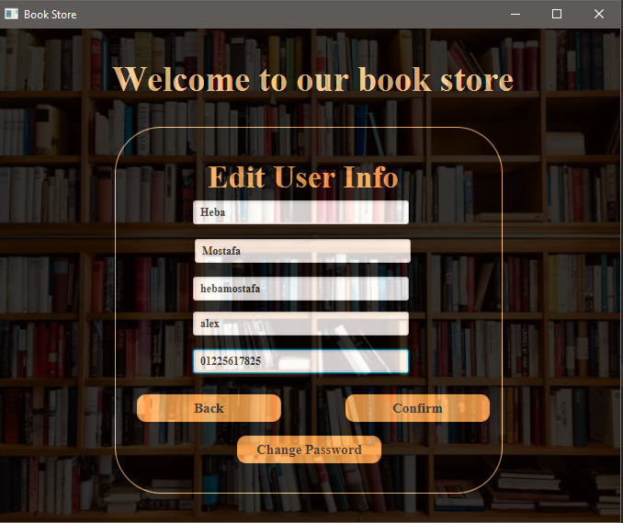

>> after editing ::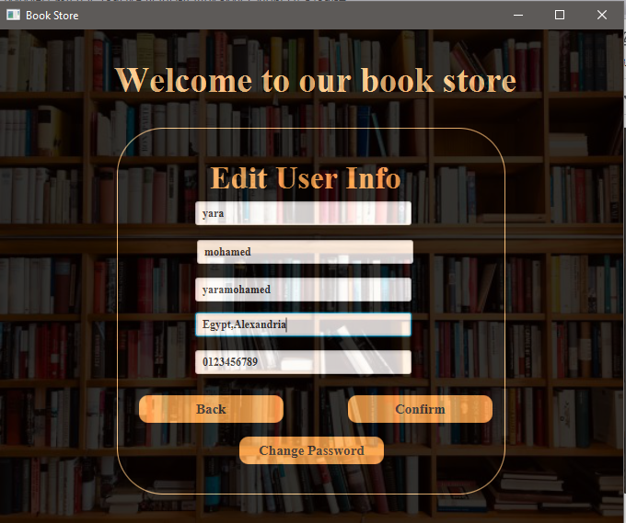

>> For Editing Password ::

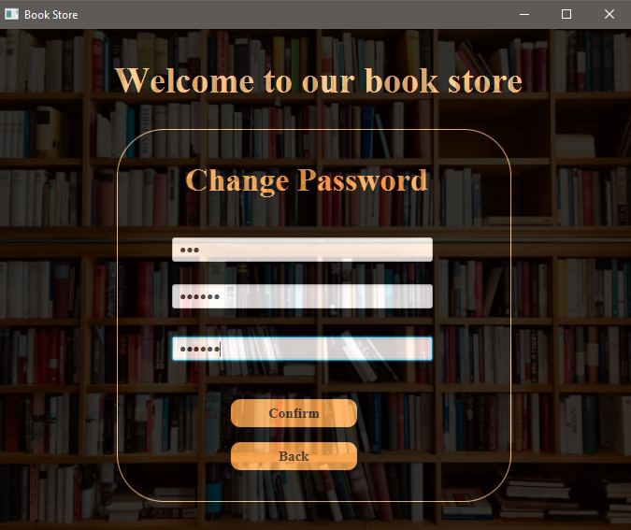

>> Entering invalid old password ::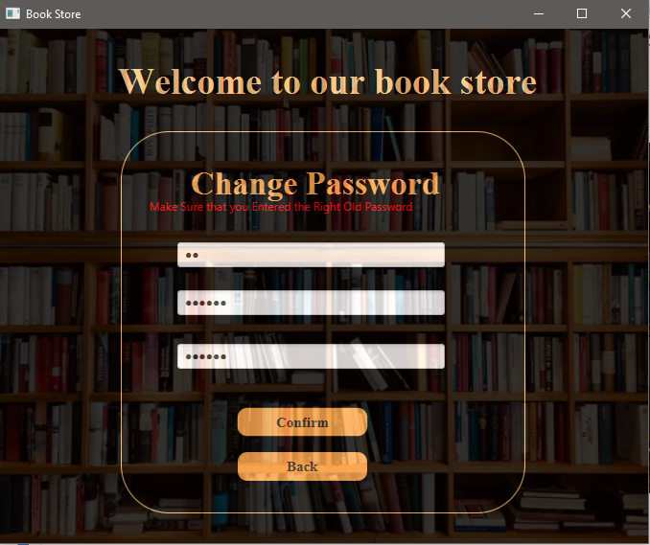

Library 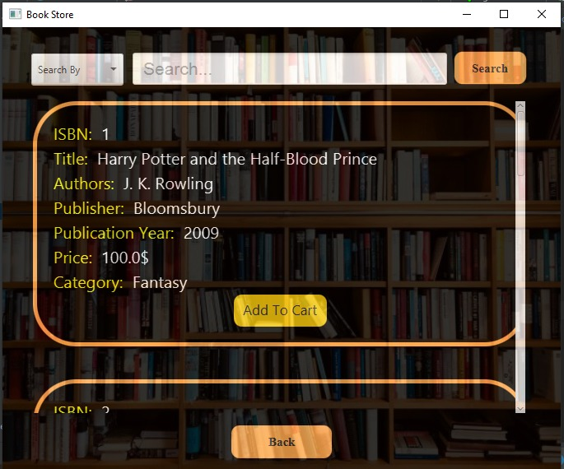

Search 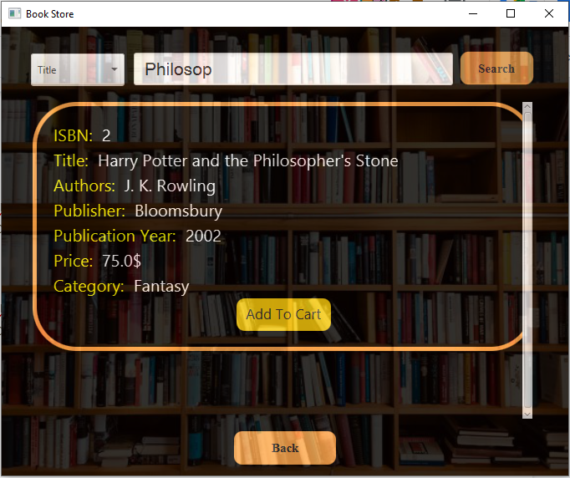

Shopping Cart

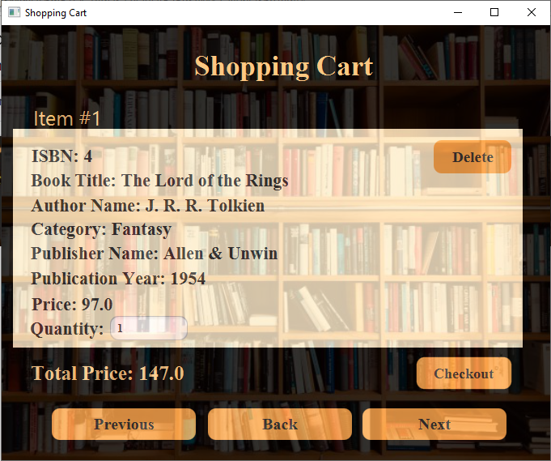

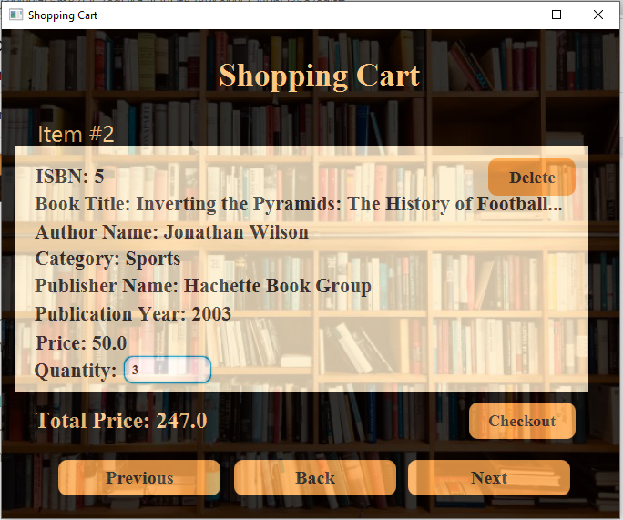

Checkout

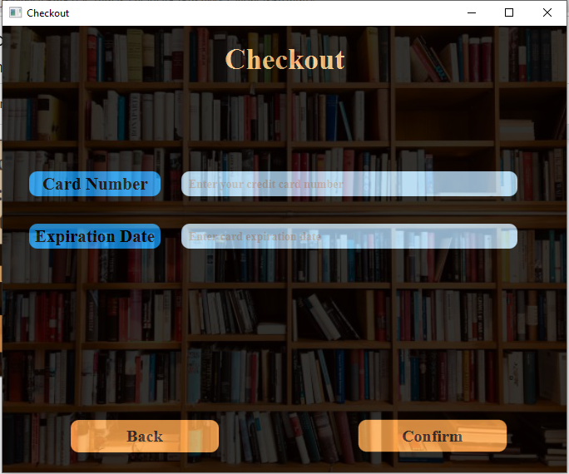

Checkout Success

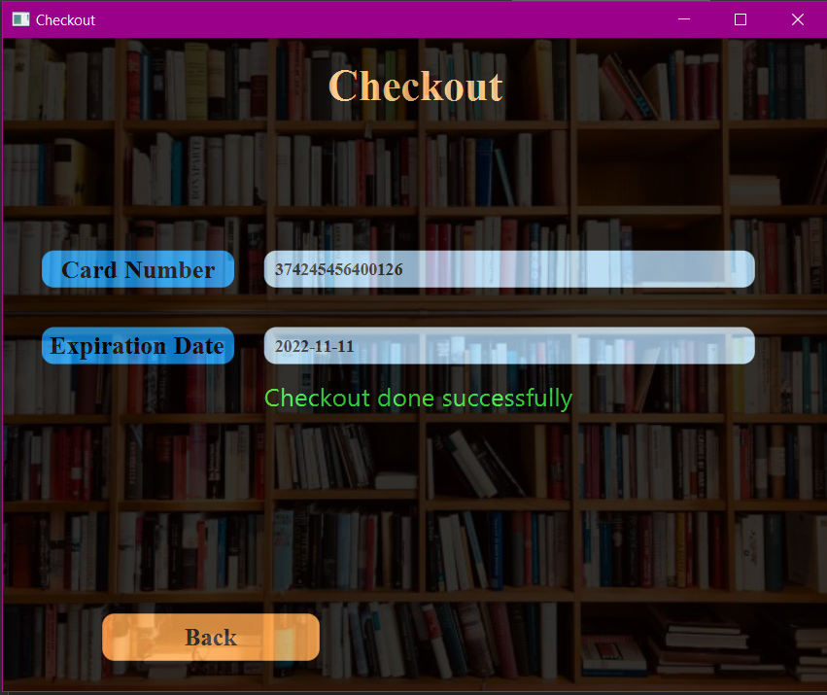

Checkout with quantities exceeding stock value

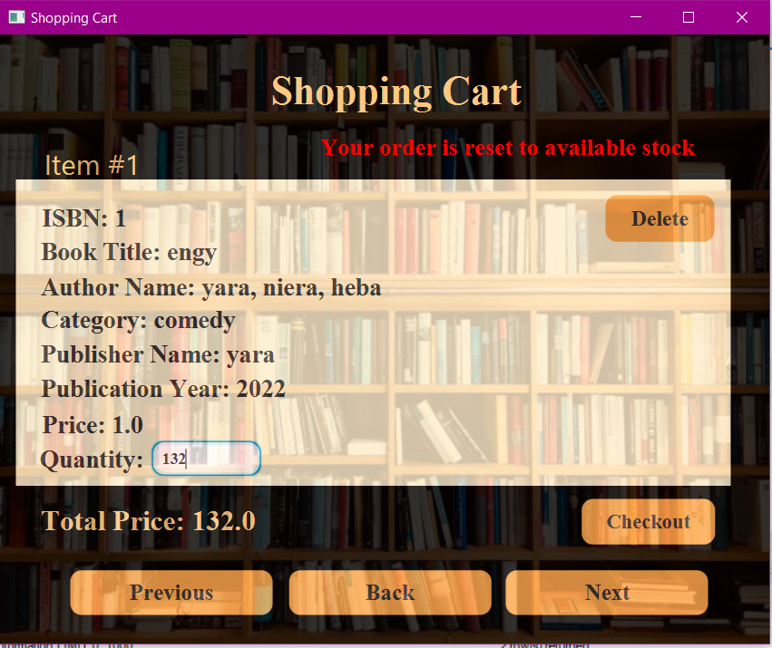

## Manager

Modify existing books

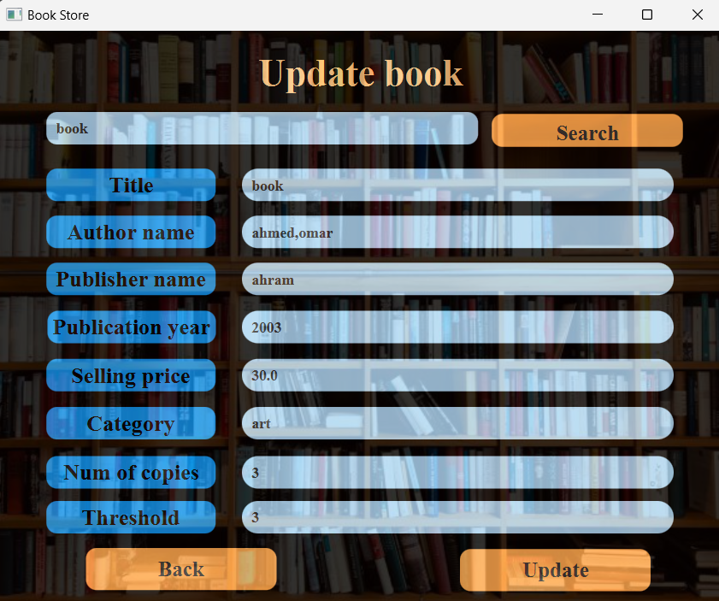

Add book

Confirm orders

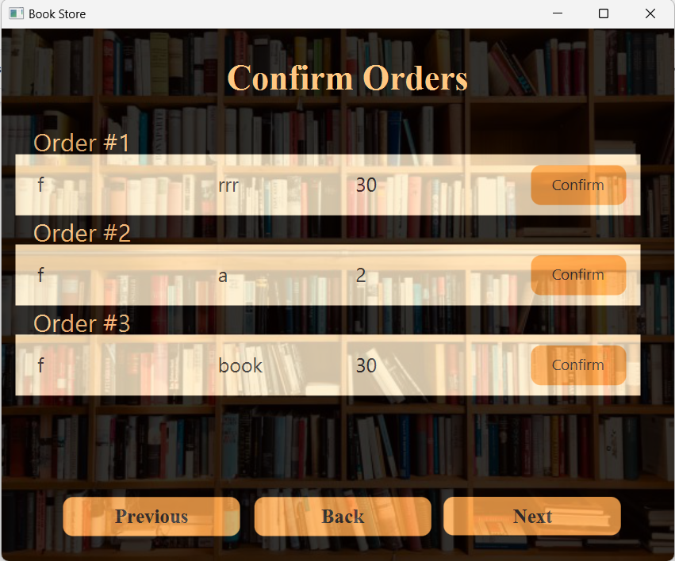

Place orders for books

Add book

